MI308X GPU测试

检测
rvs
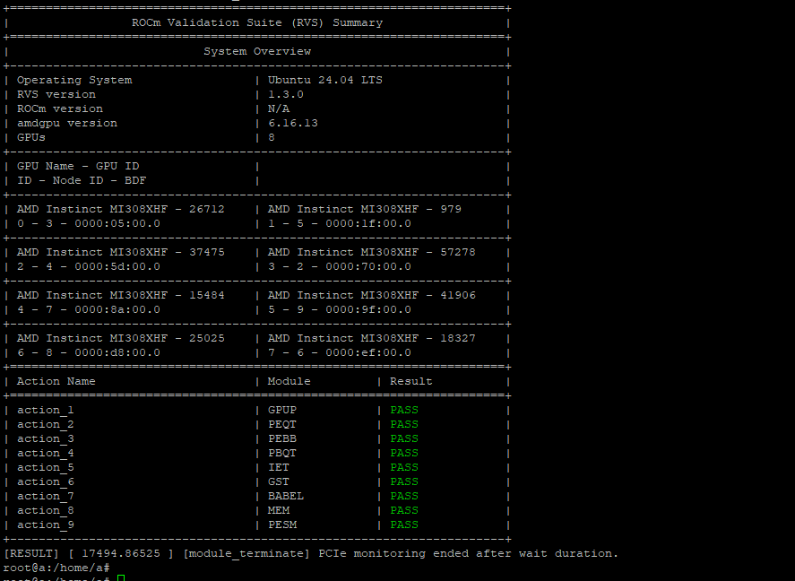

DeepSeek-v4-Flash-FP8

VLLM

rocm/atom-dev:vllm-v0.22.0-nightly_20260706

基准测试
- 启动参数
- docker run -itd \
- --ipc=host \
- --network=host \
- --privileged \
- --cap-add=CAP_SYS_ADMIN \
- --cap-add=SYS_PTRACE \
- --device=/dev/kfd \
- --device=/dev/dri \
- --security-opt seccomp=unconfined \
- --security-opt apparmor=unconfined \
- --group-add video \
- --env "NCCL_IB_GID_INDEX=3" \
- --privileged \
- --name vllm_dsv4 \
- --shm-size 128G \
- --entrypoint=/bin/bash \
- -e HIP_VISIBLE_DEVICES=0,1,2,3,4,5,6,7 \
- -e NCCL_IB_GID_INDEX=3 \
- -e AITER_BF16_FP8_MOE_BOUND=0 \
- -e ATOM_MOE_GU_ITLV=1 \
- -e VLLM_ROCM_USE_TRITON_ROPE=1 \
- -w /workspace \
- -v /data/:/data/ \
- rocm/atom-dev:vllm-v0.22.0-nightly_20260706 \
- -c "vllm serve /data/DeepSeek-V4-Flash-FP8 \
- --served-model-name=DeepSeek-V4-Flash-FP8 \
- --host 0.0.0.0 \
- --port 8001 \
- --dtype auto \
- --tensor-parallel-size 8 \
- --distributed-executor-backend mp \
- --trust-remote-code \
- --gpu-memory-utilization 0.6 \
- --tokenizer-mode deepseek_v4 \
- --block-size 16 \
- --async-scheduling \
- --no-enable-prefix-caching \
- --compilation-config '{\"cudagraph_mode\":\"FULL_AND_PIECEWISE\"}' \
- &>> /data/vllm-log/deepseek_v4_flash_fp8.log 2>&1"
- 请求测试
- 请求回复对不上，答非所问
- time curl http://0.0.0.0:8001/v1/chat/completions -H "Content-Type: application/json" -d '{
- "model": "DeepSeek-V4-Flash-FP8",
- "messages": [
- {"role": "user", "content": "1+1等于几"}
- ],
- "temperature": 0.6,
- "top_p": 0.95,
- "top_k": 20,
- "max_tokens": 2048
- }'
- {"id":"chatcmpl-a692b363def49e02","object":"chat.completion","created":1783418831,"model":"DeepSeek-V4-Flash-FP8","choices":[{"index":0,"message":{"role":"assistant","content":"1+数学二次数学等角### 1米2分5厘 小木\n\n#### Ryan < 数学下题>2分\n\n列\n\n### 1数学月 初中初中\n\n1月1、如图，已知AB直线交于AB点：∠∠∠ 1、 三角形1 中，∠∠ 度 【变】如图，将△ 5【】 如图，已知ABCD的度数为 2 解【","refusal":null,"annotations":null,"audio":null,"function_call":null,"tool_calls":[],"reasoning":null},"logprobs":null,"finish_reason":"stop","stop_reason":null,"token_ids":null,"routed_experts":null}],"service_tier":null,"system_fingerprint":"vllm-0.22.1.dev0+g0b3ba88f1.d20260706-tp8-dd6c4bea","usage":{"prompt_tokens":9,"total_tokens":109,"completion_tokens":100,"prompt_tokens_details":null},"prompt_logprobs":null,"prompt_token_ids":null,"prompt_text":null,"kv_transfer_params":null}
- real 0m1.609s
- user 0m0.003s
- sys 0m0.003s

Benchmark测试
- CONC=1
- vllm bench serve \
- --backend openai-chat \
- --base-url "http://127.0.0.1:8001" \
- --endpoint /v1/chat/completions \
- --model DeepSeek-V4-Flash-FP8 \
- --tokenizer /data/DeepSeek-V4-Flash-FP8 \
- --tokenizer-mode deepseek_v4 \
- --dataset-name random \
- --random-input-len "6144" \
- --random-output-len "1024" \
- --num-prompts $(( $CONC * 10 )) \
- --request-rate inf \
- --max-concurrency $CONC \
- --ignore-eos \
- --percentile-metrics ttft,tpot,itl,e2el
1并发测试结果
- ============ Serving Benchmark Result ============
- Successful requests: 10
- Failed requests: 0
- Maximum request concurrency: 1
- Benchmark duration (s): 165.82
- Total input tokens: 61480
- Total generated tokens: 10240
- Request throughput (req/s): 0.06
- Output token throughput (tok/s): 61.75
- Peak output token throughput (tok/s): 67.00
- Peak concurrent requests: 2.00
- Total token throughput (tok/s): 432.51
- ---------------Time to First Token----------------
- Mean TTFT (ms): 879.20
- Median TTFT (ms): 762.35
- P99 TTFT (ms): 1773.72
- -----Time per Output Token (excl. 1st token)------
- Mean TPOT (ms): 15.35
- Median TPOT (ms): 15.34
- P99 TPOT (ms): 15.77
- ---------------Inter-token Latency----------------
- Mean ITL (ms): 15.33
- Median ITL (ms): 15.12
- P99 ITL (ms): 26.87
- ----------------End-to-end Latency----------------
- Mean E2EL (ms): 16582.03
- Median E2EL (ms): 16455.93
- P99 E2EL (ms): 17530.45
- ==================================================
16并发测试结果
- ============ Serving Benchmark Result ============
- Successful requests: 160
- Failed requests: 0
- Maximum request concurrency: 16
- Benchmark duration (s): 295.44
- Total input tokens: 983680
- Total generated tokens: 163840
- Request throughput (req/s): 0.54
- Output token throughput (tok/s): 554.56
- Peak output token throughput (tok/s): 912.00
- Peak concurrent requests: 22.00
- Total token throughput (tok/s): 3884.06
- ---------------Time to First Token----------------
- Mean TTFT (ms): 3909.27
- Median TTFT (ms): 3724.72
- P99 TTFT (ms): 10986.82
- -----Time per Output Token (excl. 1st token)------
- Mean TPOT (ms): 25.05
- Median TPOT (ms): 24.89
- P99 TPOT (ms): 28.27
- ---------------Inter-token Latency----------------
- Mean ITL (ms): 25.02
- Median ITL (ms): 17.80
- P99 ITL (ms): 31.99
- ----------------End-to-end Latency----------------
- Mean E2EL (ms): 29533.76
- Median E2EL (ms): 29444.61
- P99 E2EL (ms): 36459.73
- ==================================================
6并发
- ============ Serving Benchmark Result ============
- Successful requests: 60
- Failed requests: 0
- Maximum request concurrency: 6
- Benchmark duration (s): 221.55
- Total input tokens: 368880
- Total generated tokens: 61440
- Request throughput (req/s): 0.27
- Output token throughput (tok/s): 277.32
- Peak output token throughput (tok/s): 354.00
- Peak concurrent requests: 12.00
- Total token throughput (tok/s): 1942.32
- ---------------Time to First Token----------------
- Mean TTFT (ms): 2478.76
- Median TTFT (ms): 2574.15
- P99 TTFT (ms): 4266.39
- -----Time per Output Token (excl. 1st token)------
- Mean TPOT (ms): 19.23
- Median TPOT (ms): 19.05
- P99 TPOT (ms): 20.97
- ---------------Inter-token Latency----------------
- Mean ITL (ms): 19.21
- Median ITL (ms): 17.39
- P99 ITL (ms): 28.74
- ----------------End-to-end Latency----------------
- Mean E2EL (ms): 22151.49
- Median E2EL (ms): 22136.83
- P99 E2EL (ms): 22982.17
- ==================================================

Benchmark 测试结果
- 并发数 | - 请求数 | - 输入长度 | - 输出长度 | - Input TPM (w) | - Output TPM (w) | - Total TPM (w) | - MEAN TTFT (s) | - MEAN TPOT (ms) | - MEAN E2E (s)
- 1 | - 10 | - 6144 | - 1024 | - 2.225 | - 0.370 | - 2.595 | - 0.879 | - 15.35 | - 16.58
- 16 | - 160 | - 6144 | - 1024 | - 19.977 | - 3.327 | - 23.304 | - 3.909 | - 25.05 | - 29.53
- 6 | - 60 | - 6144 | - 1024 | - 9.99 | - 1.66 | - 11.65 | - 2.478 | - 19.23 | - 22.15

locust压测
- curl --location 'http://127.0.0.1:8089/swarm' \
- --header 'Accept: */*' \
- --header 'Accept-Language: zh-CN,zh;q=0.9,en;q=0.8,de;q=0.7,zh-TW;q=0.6' \
- --header 'content-type: application/x-www-form-urlencoded' \
- --data-urlencode 'user_count=1' \
- --data-urlencode 'spawn_rate=1' \
- --data-urlencode 'host=http://127.0.0.1:8001' \
- --data-urlencode 'run_time=' \
- --data-urlencode 'profile=' \
- --data-urlencode 'api_key=' \
- --data-urlencode 'dataset_dir=' \
- --data-urlencode 'include_usage=true' \
- --data-urlencode 'interval=-1' \
- --data-urlencode 'max_tokens=16384' \
- --data-urlencode 'model_name=DeepSeek-V4-Flash-FP8' \
- --data-urlencode 'sla_interval=300' \
- --data-urlencode 'thinking_enabled=false'
6并发
- =======================================================================================================================================
- LOCUST PERFORMANCE REPORT - 2026-07-07 11:10:09
- State: running | Users: 6 | Workers: 8 | Total RPS: 1.9 | Fail Ratio: 0.0%
- ---------------------------------------------------------------------------------------------------------------------------------------
- Method | Name | Requests | Fails | Median | P95 | P99 | Average | Min | Max | RPS
- ---------------------------------------------------------------------------------------------------------------------------------------
- POST | /v1/chat/completions | 491 | 0 | 27 | 61 | 85 | 29.04 | 5 | 97 | 1.10
- POST | LLM/E2E_5x | 16 | 0 | 4 | 7 | 7 | 4.37 | 3 | 7 | 0.10
- POST | LLM/TPM_Input_5x | 16 | 0 | 48 | 64 | 64 | 46.72 | 31 | 64 | 0.10
- POST | LLM/TPM_Output_5x | 16 | 0 | 0 | 0 | 0 | 0.15 | 0 | 0 | 0.10
- POST | LLM/TPM_Total_5x | 16 | 0 | 48 | 64 | 64 | 46.87 | 31 | 64 | 0.10
- POST | LLM/TPOT_5x | 16 | 0 | 120 | 190 | 190 | 121.27 | 53 | 193 | 0.10
- POST | LLM/TTFT_5x | 16 | 0 | 1300 | 2100 | 2100 | 1363.31 | 598 | 2129 | 0.10
- POST | LLM/input_len_usage_5x | 16 | 0 | 5100 | 8300 | 8300 | 5676.59 | 3649 | 8297 | 0.10
- POST | LLM/output_len_usage_5x | 16 | 0 | 14 | 44 | 44 | 18.15 | 7 | 44 | 0.10
- - | Aggregated | 619 | 0 | 29 | 940 | 5700 | 211.14 | 0 | 8297 | 1.90
- =======================================================================================================================================
2并发
=======================================================================================================================================
LOCUST PERFORMANCE REPORT - 2026-07-08 06:16:29
State: running | Users: 2 | Workers: 8 | Total RPS: 1.8 | Fail Ratio: 0.0%
---------------------------------------------------------------------------------------------------------------------------------------
Method | Name | Requests | Fails | Median | P95 | P99 | Average | Min | Max | RPS
---------------------------------------------------------------------------------------------------------------------------------------
POST | /v1/chat/completions | 16610 | 0 | 23 | 58 | 74 | 25.89 | 4 | 139 | 1.00
POST | LLM/E2E_5x | 1661 | 0 | 2 | 3 | 4 | 1.78 | 0 | 5 | 0.10
POST | LLM/TPM_Input_5x | 1661 | 0 | 42 | 53 | 61 | 41.43 | 12 | 81 | 0.10
POST | LLM/TPM_Output_5x | 1661 | 0 | 0 | 0 | 0 | 0.12 | 0 | 1 | 0.10
POST | LLM/TPM_Total_5x | 1661 | 0 | 42 | 53 | 61 | 41.55 | 12 | 81 | 0.10
POST | LLM/TPOT_5x | 1661 | 0 | 21 | 96 | 140 | 31.57 | 1 | 200 | 0.10
POST | LLM/TTFT_5x | 1661 | 0 | 920 | 1700 | 2200 | 976.24 | 200 | 2837 | 0.10
POST | LLM/input_len_usage_5x | 1661 | 0 | 6000 | 9600 | 11000 | 6083.95 | 1273 | 16438 | 0.10
POST | LLM/output_len_usage_5x | 1661 | 0 | 16 | 38 | 52 | 17.55 | 1 | 84 | 0.10
- | Aggregated | 29898 | 0 | 26 | 3700 | 7800 | 414.06 | 0 | 16438 | 1.80
- =======================================================================================================================================
1并发
=======================================================================================================================================
LOCUST PERFORMANCE REPORT - 2026-07-08 01:25:13
State: running | Users: 1 | Workers: 8 | Total RPS: 2.4 | Fail Ratio: 0.0%
---------------------------------------------------------------------------------------------------------------------------------------
Method | Name | Requests | Fails | Median | P95 | P99 | Average | Min | Max | RPS
---------------------------------------------------------------------------------------------------------------------------------------
POST | /v1/chat/completions | 49525 | 0 | 21 | 55 | 72 | 24.54 | 3 | 128 | 0.80
POST | LLM/E2E_5x | 9905 | 0 | 1 | 2 | 2 | 0.97 | 0 | 4 | 0.20
POST | LLM/TPM_Input_5x | 9905 | 0 | 40 | 48 | 49 | 37.63 | 1 | 62 | 0.20
POST | LLM/TPM_Output_5x | 9905 | 0 | 0 | 0 | 0 | 0.09 | 0 | 0 | 0.20
POST | LLM/TPM_Total_5x | 9905 | 0 | 40 | 48 | 49 | 37.72 | 2 | 62 | 0.20
POST | LLM/TPOT_5x | 9905 | 0 | 8 | 12 | 15 | 7.32 | 0 | 20 | 0.20
POST | LLM/TTFT_5x | 9905 | 0 | 720 | 1400 | 1900 | 773.87 | 79 | 3879 | 0.20
POST | LLM/input_len_usage_5x | 9905 | 0 | 5700 | 11000 | 14000 | 6050.27 | 123 | 25333 | 0.20
POST | LLM/output_len_usage_5x | 9905 | 0 | 10 | 41 | 60 | 14.37 | 1 | 148 | 0.20
- | Aggregated | 128765 | 0 | 22 | 4700 | 9200 | 541.92 | 0 | 25333 | 2.40
- =======================================================================================================================================

rocm/atom-dev:vllm-dsv4-sharedmap-fix-20260708_181308

基准测试
- 启动参数
- docker run -itd \
- --ipc=host \
- --network=host \
- --privileged \
- --cap-add=CAP_SYS_ADMIN \
- --cap-add=SYS_PTRACE \
- --device=/dev/kfd \
- --device=/dev/dri \
- --security-opt seccomp=unconfined \
- --security-opt apparmor=unconfined \
- --group-add video \
- --env "NCCL_IB_GID_INDEX=3" \
- --privileged \
- --name vllm_dsv4 \
- --shm-size 128G \
- --entrypoint=/bin/bash \
- -e HIP_VISIBLE_DEVICES=0,1,2,3,4,5,6,7 \
- -e NCCL_IB_GID_INDEX=3 \
- -e AITER_BF16_FP8_MOE_BOUND=0 \
- -e ATOM_MOE_GU_ITLV=1 \
- -e VLLM_ROCM_USE_TRITON_ROPE=1 \
- -w /workspace \
- -v /data/:/data/ \
- rocm/atom-dev:vllm-dsv4-sharedmap-fix-20260708_181308 \
- -c "vllm serve /data/DeepSeek-V4-Flash-FP8 \
- --served-model-name=DeepSeek-V4-Flash-FP8 \
- --host 0.0.0.0 \
- --port 8001 \
- --dtype auto \
- --tensor-parallel-size 8 \
- --distributed-executor-backend mp \
- --trust-remote-code \
- --gpu-memory-utilization 0.6 \
- --tokenizer-mode deepseek_v4 \
- --block-size 16 \
- --async-scheduling \
- --no-enable-prefix-caching \
- --compilation-config '{\"cudagraph_mode\":\"FULL_AND_PIECEWISE\"}' \
- &>> /data/vllm-log/deepseek_v4_flash_fp8.log 2>&1"
- 请求测试
- time curl http://0.0.0.0:8001/v1/chat/completions -H "Content-Type: application/json" -d '{
- "model": "DeepSeek-V4-Flash-FP8",
- "messages": [
- {"role": "user", "content": "1+1等于几"}
- ],
- "temperature": 0.6,
- "top_p": 0.95,
- "top_k": 20,
- "max_tokens": 2048
- }'
- {"id":"chatcmpl-9fa14d49dbacd6e0","object":"chat.completion","created":1783568983,"model":"DeepSeek-V4-Flash-FP8","choices":[{"index":0,"message":{"role":"assistant","content":"1+1 等于 **2**。 \n\n这是数学中最基础的加法运算。在十进制算术系统中，1 加 1 的结果就是 2。","refusal":null,"annotations":null,"audio":null,"function_call":null,"tool_calls":[],"reasoning":null},"logprobs":null,"finish_reason":"stop","stop_reason":null,"token_ids":null,"routed_experts":null}],"service_tier":null,"system_fingerprint":"vllm-0.22.1.dev0+g0b3ba88f1.d20260705-tp8-a2477789","usage":{"prompt_tokens":9,"total_tokens":43,"completion_tokens":34,"prompt_tokens_details":null},"prompt_logprobs":null,"prompt_token_ids":null,"prompt_text":null,"kv_transfer_params":null}
- real 0m0.725s
- user 0m0.004s
- sys 0m0.009s
- Benchmark测试
- CONC=1
- vllm bench serve \
- --backend openai-chat \
- --base-url "http://127.0.0.1:8001" \
- --endpoint /v1/chat/completions \
- --model DeepSeek-V4-Flash-FP8 \
- --tokenizer /data/DeepSeek-V4-Flash-FP8 \
- --tokenizer-mode deepseek_v4 \
- --dataset-name random \
- --random-input-len "6144" \
- --random-output-len "1024" \
- --num-prompts $(( $CONC * 10 )) \
- --request-rate inf \
- --max-concurrency $CONC \
- --ignore-eos \
- --percentile-metrics ttft,tpot,itl,e2el
并发1
- ============ Serving Benchmark Result ============
- Successful requests: 10
- Failed requests: 0
- Maximum request concurrency: 1
- Benchmark duration (s): 190.73
- Total input tokens: 61480
- Total generated tokens: 10240
- Request throughput (req/s): 0.05
- Output token throughput (tok/s): 53.69
- Peak output token throughput (tok/s): 57.00
- Peak concurrent requests: 2.00
- Total token throughput (tok/s): 376.03
- ---------------Time to First Token----------------
- Mean TTFT (ms): 851.88
- Median TTFT (ms): 778.74
- P99 TTFT (ms): 1465.27
- -----Time per Output Token (excl. 1st token)------
- Mean TPOT (ms): 17.81
- Median TPOT (ms): 17.81
- P99 TPOT (ms): 17.82
- ---------------Inter-token Latency----------------
- Mean ITL (ms): 17.79
- Median ITL (ms): 17.81
- P99 ITL (ms): 18.11
- ----------------End-to-end Latency----------------
- Mean E2EL (ms): 19072.44
- Median E2EL (ms): 18997.76
- P99 E2EL (ms): 19682.00
- ==================================================
并发6
- ============ Serving Benchmark Result ============
- Successful requests: 60
- Failed requests: 0
- Maximum request concurrency: 6
- Benchmark duration (s): 244.94
- Total input tokens: 368880
- Total generated tokens: 61440
- Request throughput (req/s): 0.24
- Output token throughput (tok/s): 250.84
- Peak output token throughput (tok/s): 318.00
- Peak concurrent requests: 12.00
- Total token throughput (tok/s): 1756.86
- ---------------Time to First Token----------------
- Mean TTFT (ms): 2804.08
- Median TTFT (ms): 3286.61
- P99 TTFT (ms): 5281.26
- -----Time per Output Token (excl. 1st token)------
- Mean TPOT (ms): 21.20
- Median TPOT (ms): 20.82
- P99 TPOT (ms): 23.43
- ---------------Inter-token Latency----------------
- Mean ITL (ms): 21.18
- Median ITL (ms): 19.58
- P99 ITL (ms): 19.98
- ----------------End-to-end Latency----------------
- Mean E2EL (ms): 24489.80
- Median E2EL (ms): 24437.26
- P99 E2EL (ms): 25572.92
- ==================================================
并发4
- ============ Serving Benchmark Result ============
- Successful requests: 40
- Failed requests: 0
- Maximum request concurrency: 4
- Benchmark duration (s): 224.53
- Total input tokens: 245920
- Total generated tokens: 40960
- Request throughput (req/s): 0.18
- Output token throughput (tok/s): 182.43
- Peak output token throughput (tok/s): 212.00
- Peak concurrent requests: 8.00
- Total token throughput (tok/s): 1277.72
- ---------------Time to First Token----------------
- Mean TTFT (ms): 2046.36
- Median TTFT (ms): 2118.32
- P99 TTFT (ms): 3023.35
- -----Time per Output Token (excl. 1st token)------
- Mean TPOT (ms): 19.94
- Median TPOT (ms): 19.91
- P99 TPOT (ms): 21.17
- ---------------Inter-token Latency----------------
- Mean ITL (ms): 19.92
- Median ITL (ms): 19.05
- P99 ITL (ms): 19.37
- ----------------End-to-end Latency----------------
- Mean E2EL (ms): 22449.09
- Median E2EL (ms): 22440.19
- P99 E2EL (ms): 22548.02
- ==================================================

Benchmark 测试结果
- 并发数 | - 请求数 | - 输入长度 | - 输出长度 | - Input TPM (w) | - Output TPM (w) | - Total TPM (w) | - MEAN TTFT (s) | - MEAN TPOT (ms) | - MEAN E2E (s)
- 1 | - 10 | - 6144 | - 1024 | - 1.93 | - 0.322 | - 2.256 | - 0.851 | - 17.81 | - 19.07
- 6 | - 160 | - 6144 | - 1024 | - 9.03 | - 1.50 | - 10.54 | - 3.804 | - 21.20 | - 24.49
- 4 | - 60 | - 6144 | - 1024 | - 6.57 | - 1.09 | - 7.66 | - 2.046 | - 19.94 | - 22.45

locust压测
- # 1. 启动 locust 容器
- docker run -d \
- --network=host \
- -v /etc/localtime:/etc/localtime:ro \
- --shm-size=64g \
- --ipc=host \
- --privileged=true \
- --name locust-8089 \
- --entrypoint bash \
- locust-awcloud:1.5 \
- -c "sleep infinity"

- # 2. 启动 locust 服务
- docker exec -it locust-8089 bash
- cd /root/locust_test/
- nohup ./start_locust.sh &
4并发
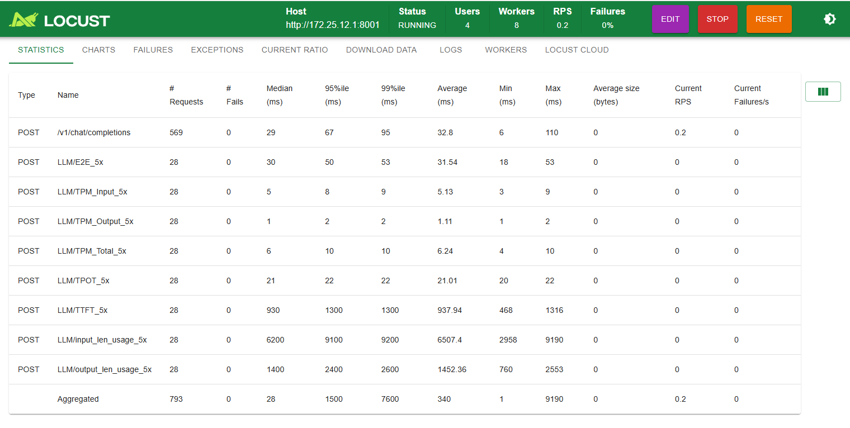
2并发
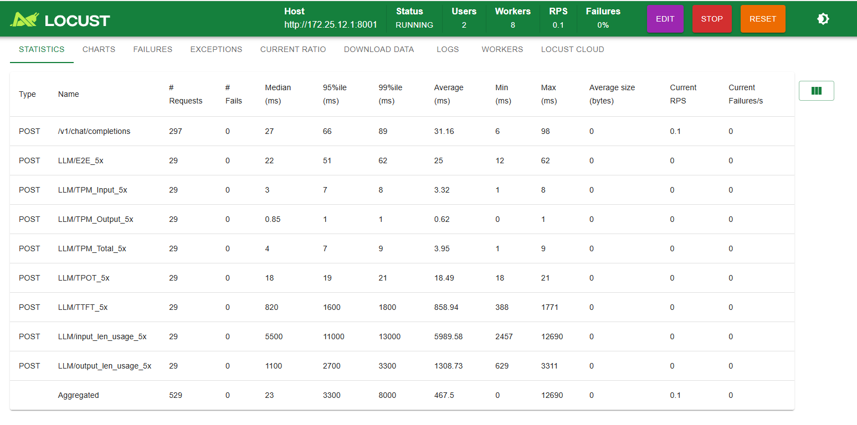
3并发
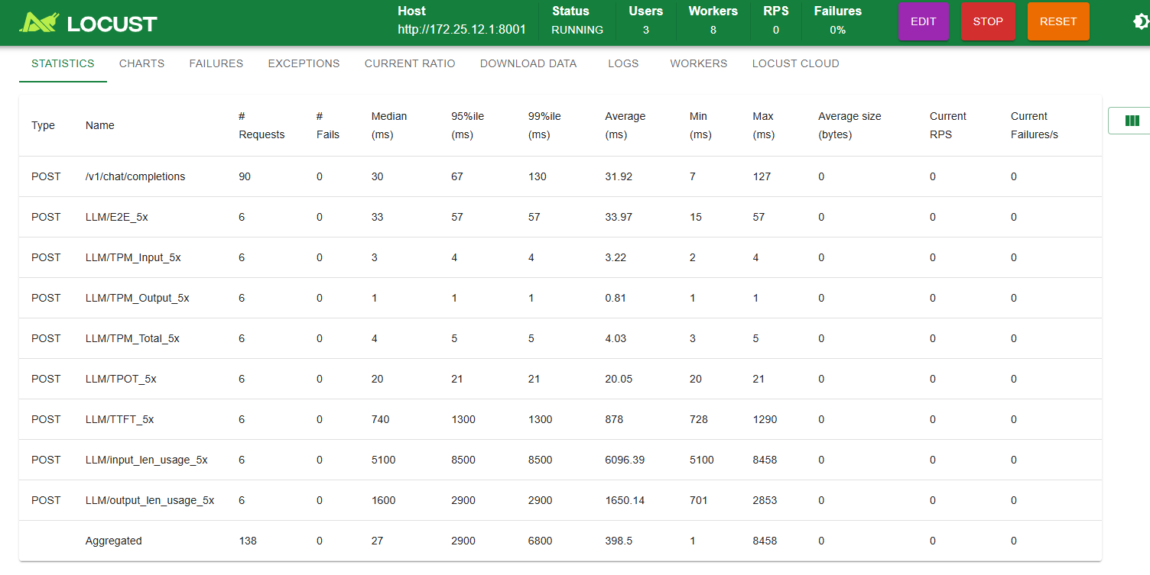

调优测试
- -e VLLM_ROCM_QUICK_REDUCE_ENABLE=1 \
- -e VLLM_ROCM_QUICK_REDUCE_QUANTIZATION=INT4 \
Benchmark测试
1并发
- ============ Serving Benchmark Result ============
- Successful requests: 10
- Failed requests: 0
- Maximum request concurrency: 1
- Benchmark duration (s): 192.18
- Total input tokens: 61480
- Total generated tokens: 10240
- Request throughput (req/s): 0.05
- Output token throughput (tok/s): 53.28
- Peak output token throughput (tok/s): 57.00
- Peak concurrent requests: 2.00
- Total token throughput (tok/s): 373.19
- ---------------Time to First Token----------------
- Mean TTFT (ms): 975.08
- Median TTFT (ms): 775.32
- P99 TTFT (ms): 2600.30
- -----Time per Output Token (excl. 1st token)------
- Mean TPOT (ms): 17.83
- Median TPOT (ms): 17.83
- P99 TPOT (ms): 17.85
- ---------------Inter-token Latency----------------
- Mean ITL (ms): 17.81
- Median ITL (ms): 17.83
- P99 ITL (ms): 18.10
- ----------------End-to-end Latency----------------
- Mean E2EL (ms): 19217.55
- Median E2EL (ms): 19019.56
- P99 E2EL (ms): 20837.36
- ==================================================
4并发
- ============ Serving Benchmark Result ============
- Successful requests: 40
- Failed requests: 0
- Maximum request concurrency: 4
- Benchmark duration (s): 225.66
- Total input tokens: 245920
- Total generated tokens: 40960
- Request throughput (req/s): 0.18
- Output token throughput (tok/s): 181.51
- Peak output token throughput (tok/s): 212.00
- Peak concurrent requests: 8.00
- Total token throughput (tok/s): 1271.28
- ---------------Time to First Token----------------
- Mean TTFT (ms): 2091.10
- Median TTFT (ms): 2383.77
- P99 TTFT (ms): 3449.11
- -----Time per Output Token (excl. 1st token)------
- Mean TPOT (ms): 20.01
- Median TPOT (ms): 19.92
- P99 TPOT (ms): 21.62
- ---------------Inter-token Latency----------------
- Mean ITL (ms): 19.99
- Median ITL (ms): 19.07
- P99 ITL (ms): 19.39
- ----------------End-to-end Latency----------------
- Mean E2EL (ms): 22562.80
- Median E2EL (ms): 22480.86
- P99 E2EL (ms): 22986.74
- ==================================================

Benchmark 测试结果
- 并发数 | - 请求数 | - 输入长度 | - 输出长度 | - Input TPM (w) | - Output TPM (w) | - Total TPM (w) | - MEAN TTFT (s) | - MEAN TPOT (ms) | - MEAN E2E (s)
- 1 | - 10 | - 6144 | - 1024 | - 1.92 | - 0.319 | - 2.24 | - 0.975 | - 17.83 | - 19.21
- 4 | - 60 | - 6144 | - 1024 | - 6.54 | - 1.09 | - 7.627 | - 2.091 | - 20.01 | - 22.56

locust压测
3并发
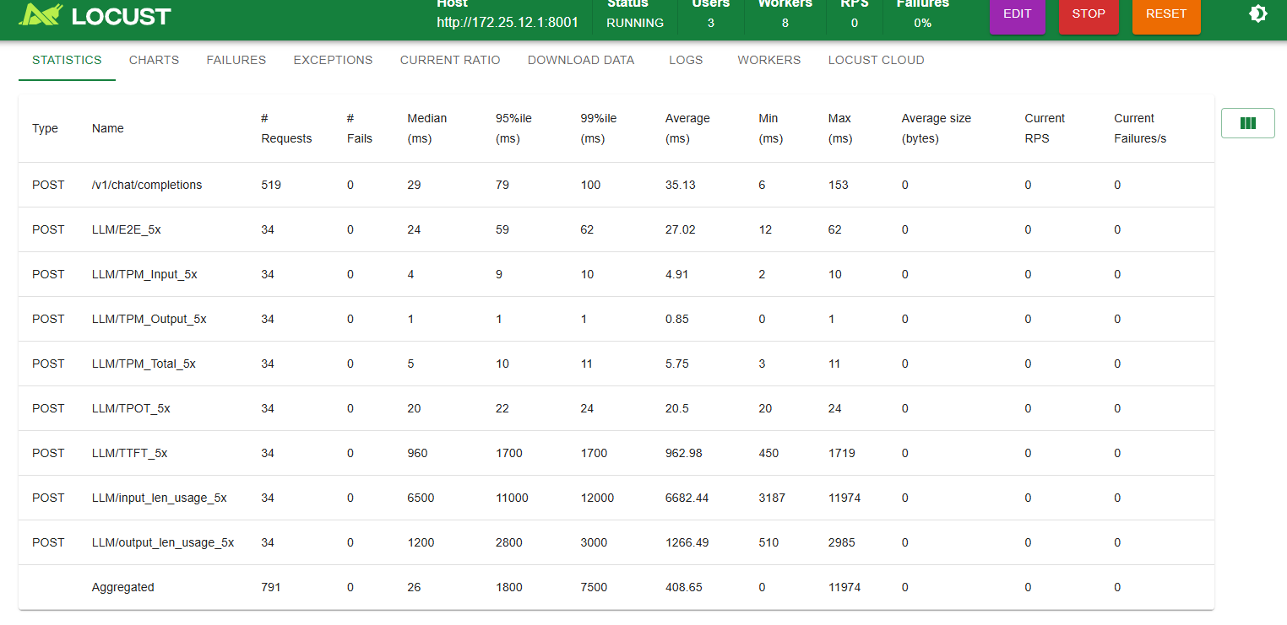
18并发
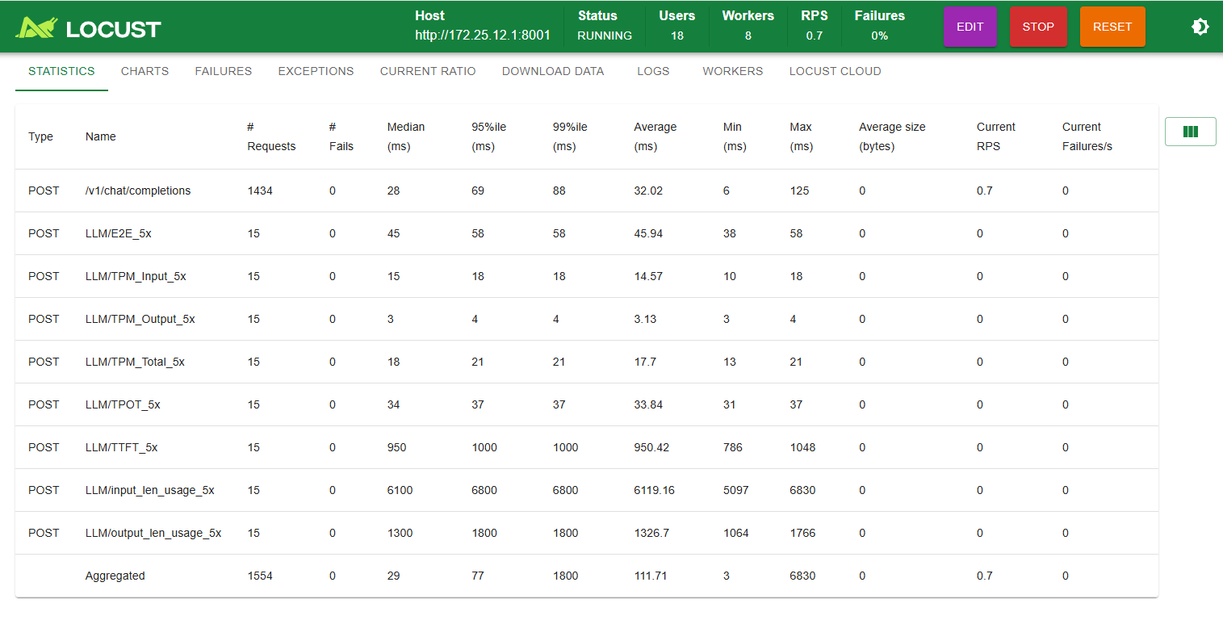

调优测试2
- -e VLLM_ROCM_QUICK_REDUCE_ENABLE=1 \
-e VLLM_ROCM_QUICK_REDUCE_QUANTIZATION=INT4 \
-e NCCL_MIN_NCHANNELS=112 \
-e HIP_FORCE_DEV_KERNARG=1 \
-e SAFETENSORS_FAST_GPU=1 \
- -e TORCH_BLAS_PREFER_HIPBLASLT=1 \
- Benchmark测试
- 1并发
============ Serving Benchmark Result ============
Successful requests: 10
Failed requests: 0
Maximum request concurrency: 1
Benchmark duration (s): 192.28
Total input tokens: 61480
Total generated tokens: 10240
Request throughput (req/s): 0.05
Output token throughput (tok/s): 53.25
Peak output token throughput (tok/s): 58.00
Peak concurrent requests: 2.00
Total token throughput (tok/s): 372.99
---------------Time to First Token----------------
Mean TTFT (ms): 984.10
Median TTFT (ms): 779.16
P99 TTFT (ms): 2656.94
-----Time per Output Token (excl. 1st token)------
Mean TPOT (ms): 17.83
Median TPOT (ms): 17.83
P99 TPOT (ms): 17.85
---------------Inter-token Latency----------------
Mean ITL (ms): 17.82
Median ITL (ms): 17.84
P99 ITL (ms): 18.12
----------------End-to-end Latency----------------
Mean E2EL (ms): 19227.94
Median E2EL (ms): 19025.63
P99 E2EL (ms): 20878.19
==================================================

- 4并发
============ Serving Benchmark Result ============
Successful requests: 40
Failed requests: 0
Maximum request concurrency: 4
Benchmark duration (s): 225.37
Total input tokens: 245920
Total generated tokens: 40960
Request throughput (req/s): 0.18
Output token throughput (tok/s): 181.75
Peak output token throughput (tok/s): 212.00
Peak concurrent requests: 8.00
Total token throughput (tok/s): 1272.93
---------------Time to First Token----------------
Mean TTFT (ms): 2094.63
Median TTFT (ms): 2389.98
P99 TTFT (ms): 3459.00
-----Time per Output Token (excl. 1st token)------
Mean TPOT (ms): 19.98
Median TPOT (ms): 19.87
P99 TPOT (ms): 21.57
---------------Inter-token Latency----------------
Mean ITL (ms): 19.96
Median ITL (ms): 19.04
P99 ITL (ms): 19.53
----------------End-to-end Latency----------------
Mean E2EL (ms): 22533.63
Median E2EL (ms): 22455.95
P99 E2EL (ms): 22952.96
- ==================================================

Benchmark 测试结果
- 并发数 | - 请求数 | - 输入长度 | - 输出长度 | - Input TPM (w) | - Output TPM (w) | - Total TPM (w) | - MEAN TTFT (s) | - MEAN TPOT (ms) | - MEAN E2E (s)
- 1 | - 10 | - 6144 | - 1024 | - 1.918 | - 0.319 | - 2.237 | - 0.984 | - 17.83 | - 19.22
- 4 | - 60 | - 6144 | - 1024 | - 6.547 | - 1.09 | - 7.637 | - 2.094 | - 19.98 | - 22.53

locust压测
3并发
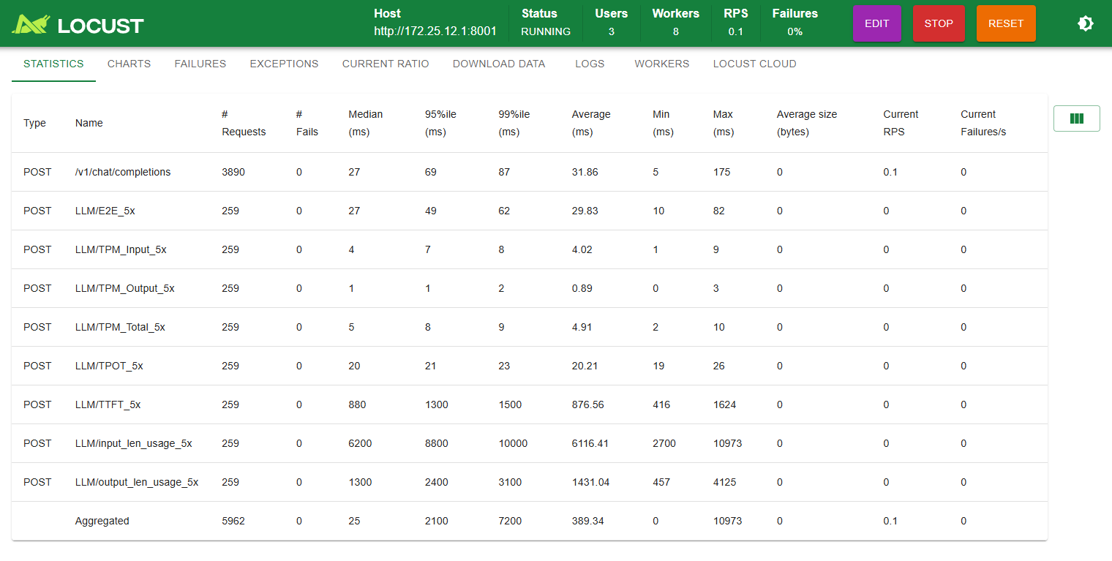

SGLANG

lmsysorg/sglang-rocm:v0.5.13.post1-rocm720-mi30x-20260623

基准测试
- 启动参数
- docker run -itd \
- --ipc=host \
- --network=host \
- --privileged \
- --cap-add=CAP_SYS_ADMIN \
- --cap-add=SYS_PTRACE \
- --device=/dev/kfd \
- --device=/dev/dri \
- --security-opt seccomp=unconfined \
- --security-opt apparmor=unconfined \
- --group-add video \
- --name sglang_dsv4 \
- --shm-size 128G \
- -w /workspace \
- -v /data/:/data/ \
- -e HIP_VISIBLE_DEVICES=0,1,2,3,4,5,6,7 \
- -e SGLANG_USE_ROCM700A=0 \
- -e SGLANG_HACK_FLASHMLA_BACKEND=unified_kv_triton \
- -e AITER_BF16_FP8_MOE_BOUND=0 \
- --entrypoint=/bin/bash \
- lmsysorg/sglang-rocm:v0.5.13.post1-rocm720-mi30x-20260623 \
- -c "sglang serve \
- --trust-remote-code \
- --model-path /data/DeepSeek-V4-Flash-FP8 \
- --tp 8 \
- --attention-backend dsv4 \
- --page-size 256 \
- --mem-fraction-static 0.90 \
- --swa-full-tokens-ratio 0.1 \
- --disable-shared-experts-fusion \
- --kv-cache-dtype fp8_e4m3 \
- --chunked-prefill-size 8192 \
- --speculative-algorithm EAGLE \
- --speculative-num-steps 3 \
- --speculative-eagle-topk 1 \
- --speculative-num-draft-tokens 4 \
- --host 0.0.0.0 \
- --port 30000 \
- &>> /data/sglang-log/sglang_deepseek_v4.log 2>&1"
- 请求测试
- time curl http://0.0.0.0:30000/v1/chat/completions -H "Content-Type: application/json" -d '{
- "model": "DeepSeek-V4-Flash-FP8",
- "messages": [
- {"role": "user", "content": "现在你的身份是刘备，而我是关羽，请在这个背景下完成对话。大哥，我等何日光复大汉"}
- ],
- "temperature": 0.6,
- "top_p": 0.95,
- "top_k": 20,
- "max_tokens": 2048
- }'
- {"id":"efbbde5648e644dfb6a6fa32337e596d","object":"chat.completion","created":1783392796,"model":"DeepSeek-V4-Flash-FP8","choices":[{"index":0,"message":{"role":"assistant","content":"（执手落泪）二弟啊！自桃园结义至今，你我兄弟辗转半生，虽据荆州一隅，然汉贼未除，天下未定。今曹操虎踞中原，孙权暗怀异心，你我当效光武之志，待益州根基稳固，便当挥师北上，克复长安洛阳，重振汉室宗庙！","reasoning_content":null,"tool_calls":null},"logprobs":null,"finish_reason":"stop","matched_stop":1}],"usage":{"prompt_tokens":27,"total_tokens":111,"completion_tokens":84,"prompt_tokens_details":null,"reasoning_tokens":0},"metadata":{"weight_version":"default"}}
- real 0m1.702s
- user 0m0.001s
- sys 0m0.005s
- Benchmark
- CONC=16

- python -m sglang.bench_serving \
- --backend sglang-oai-chat \
- --base-url "http://127.0.0.1:30000" \
- --model /data/DeepSeek-V4-Flash-FP8 \
- --dataset-name random \
- --random-input-len 6144 \
- --random-output-len 1024 \
- --random-range-ratio 1.0 \
- --num-prompts $(( $CONC * 8 )) \
- --request-rate inf \
- --max-concurrency $CONC

benchmark测试故障
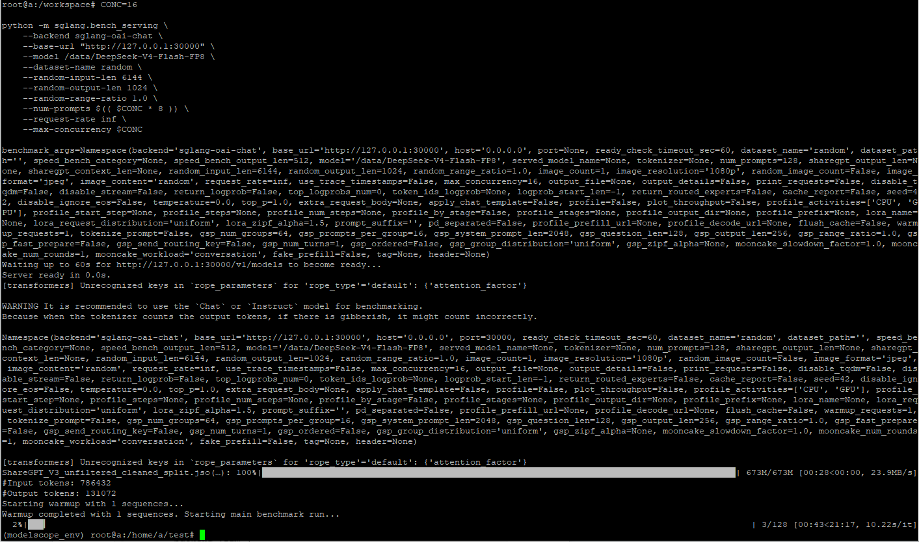
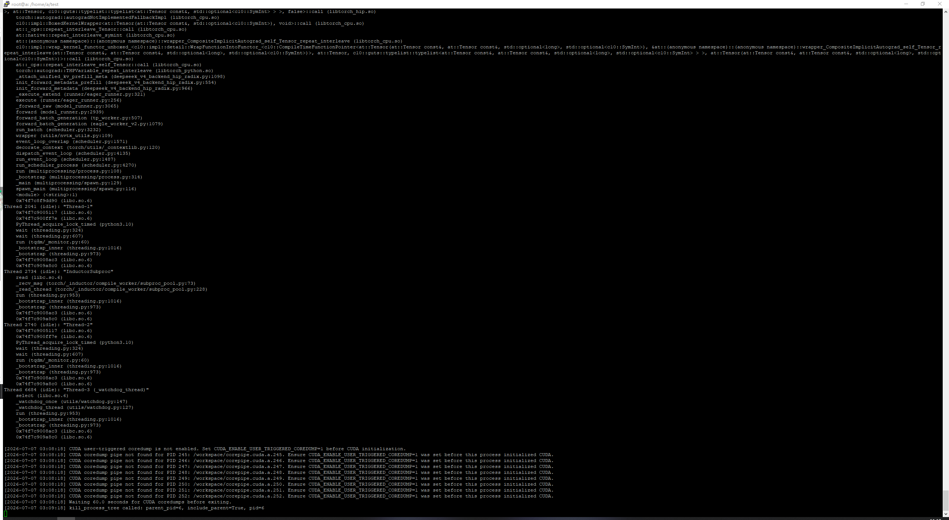

lmsysorg/sglang-rocm:v0.5.13.post1-rocm720-mi30x-20260625

基准测试
- 启动参数
- docker run -itd \
- --ipc=host \
- --network=host \
- --privileged \
- --cap-add=CAP_SYS_ADMIN \
- --cap-add=SYS_PTRACE \
- --device=/dev/kfd \
- --device=/dev/dri \
- --security-opt seccomp=unconfined \
- --security-opt apparmor=unconfined \
- --group-add video \
- --name sglang_dsv4 \
- --shm-size 128G \
- -w /workspace \
- -v /data/:/data/ \
- -e HIP_VISIBLE_DEVICES=0,1,2,3,4,5,6,7 \
- -e SGLANG_USE_ROCM700A=0 \
- -e SGLANG_HACK_FLASHMLA_BACKEND=unified_kv_triton \
- -e AITER_BF16_FP8_MOE_BOUND=0 \
- --entrypoint=/bin/bash \
- lmsysorg/sglang-rocm:v0.5.13.post1-rocm720-mi30x-20260625 \
- -c "sglang serve \
- --trust-remote-code \
- --model-path /data/DeepSeek-V4-Flash-FP8 \
- --tp 8 \
- --attention-backend dsv4 \
- --page-size 256 \
- --mem-fraction-static 0.90 \
- --swa-full-tokens-ratio 0.1 \
- --disable-shared-experts-fusion \
- --kv-cache-dtype fp8_e4m3 \
- --chunked-prefill-size 8192 \
- --speculative-algorithm EAGLE \
- --speculative-num-steps 3 \
- --speculative-eagle-topk 1 \
- --speculative-num-draft-tokens 4 \
- --host 0.0.0.0 \
- --port 30000 \
- &>> /data/sglang-log/sglang_deepseek_v4.log 2>&1"
- 请求测试
- time curl http://0.0.0.0:30000/v1/chat/completions -H "Content-Type: application/json" -d '{
- "model": "DeepSeek-V4-Flash-FP8",
- "messages": [
- {"role": "user", "content": "现在你的身份是刘备，而我是关羽，请在这个背景下完成对话。大哥，我等何日光复大汉"}
- ],
- "temperature": 0.6,
- "top_p": 0.95,
- "top_k": 20,
- "max_tokens": 2048
- }'
- {"id":"4c89c98c7895465eac050df421fb6b28","object":"chat.completion","created":1783403904,"model":"DeepSeek-V4-Flash-FP8","choices":[{"index":0,"message":{"role":"assistant","content":"（执手落泪）二弟啊！自桃园结义至今，你我兄弟辗转半生，今虽据荆州一隅，然汉贼未除，天下未定。昨夜观星，见紫微晦暗，恐非举事之时。然弟且宽心，待孔明军师自江东归来，必与弟共商大计。","reasoning_content":null,"tool_calls":null},"logprobs":null,"finish_reason":"stop","matched_stop":1}],"usage":{"prompt_tokens":27,"total_tokens":107,"completion_tokens":80,"prompt_tokens_details":null,"reasoning_tokens":0},"metadata":{"weight_version":"default"}}
- real 0m1.575s
- user 0m0.003s
- sys 0m0.003s
- Benchmark
- CONC=1

- python -m sglang.bench_serving \
- --backend sglang-oai-chat \
- --base-url "http://127.0.0.1:30000" \
- --model /data/DeepSeek-V4-Flash-FP8 \
- --dataset-name random \
- --random-input-len 6144 \
- --random-output-len 1024 \
- --random-range-ratio 1.0 \
- --num-prompts $(( $CONC * 8 )) \
- --request-rate inf \
- --max-concurrency $CONC

- 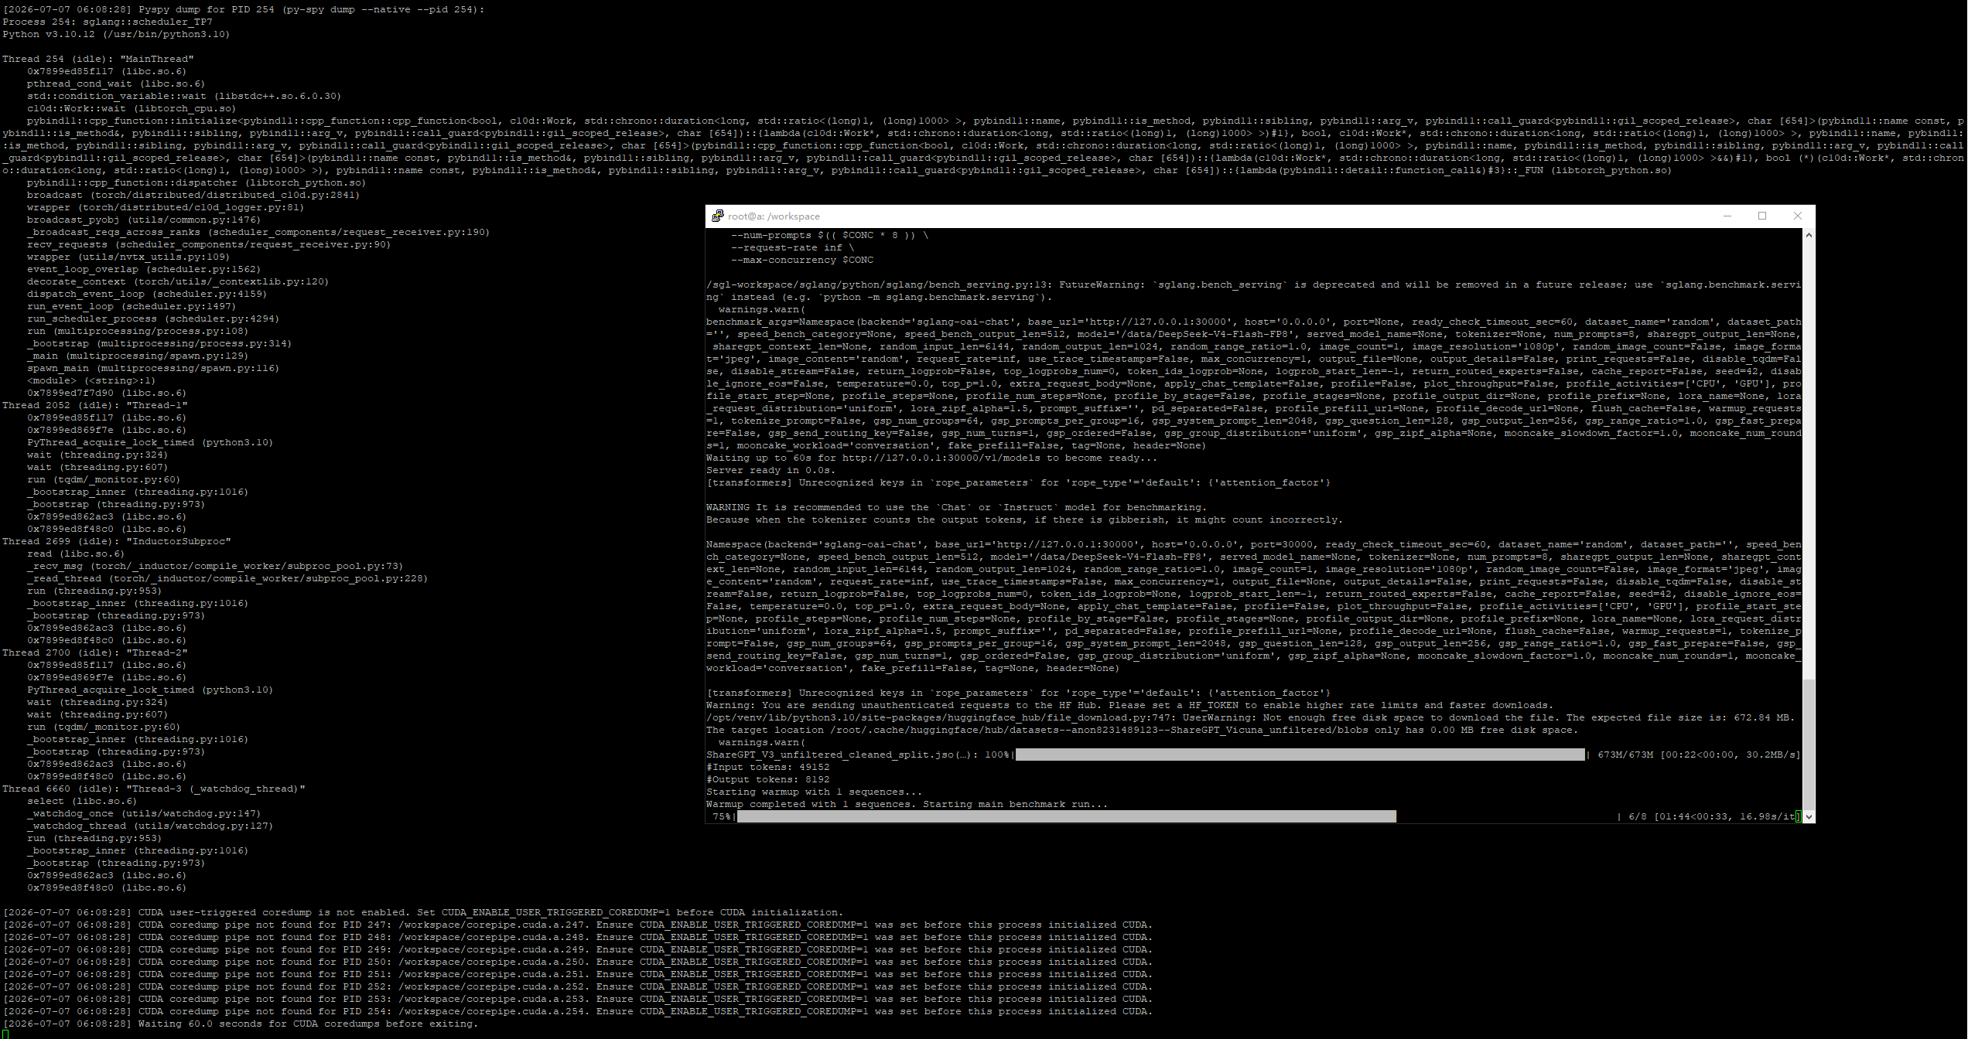

不开启MTP
- 启动参数
- docker run -itd \
- --ipc=host \
- --network=host \
- --privileged \
- --cap-add=CAP_SYS_ADMIN \
- --cap-add=SYS_PTRACE \
- --device=/dev/kfd \
- --device=/dev/dri \
- --security-opt seccomp=unconfined \
- --security-opt apparmor=unconfined \
- --group-add video \
- --name sglang_dsv4 \
- --shm-size 128G \
- -w /workspace \
- -v /data/:/data/ \
- -e HIP_VISIBLE_DEVICES=0,1,2,3,4,5,6,7 \
- -e SGLANG_USE_ROCM700A=0 \
- -e SGLANG_HACK_FLASHMLA_BACKEND=unified_kv_triton \
- -e AITER_BF16_FP8_MOE_BOUND=0 \
- --entrypoint=/bin/bash \
- lmsysorg/sglang-rocm:v0.5.13.post1-rocm720-mi30x-20260625 \
- -c "sglang serve \
- --trust-remote-code \
- --model-path /data/DeepSeek-V4-Flash-FP8 \
- --tp 8 \
- --attention-backend dsv4 \
- --page-size 256 \
- --mem-fraction-static 0.90 \
- --swa-full-tokens-ratio 0.1 \
- --disable-shared-experts-fusion \
- --kv-cache-dtype fp8_e4m3 \
- --chunked-prefill-size 8192 \
- --host 0.0.0.0 \
- --port 30000 \
- &>> /data/sglang-log/sglang_deepseek_v4.log 2>&1"
- 请求测试
- time curl http://0.0.0.0:30000/v1/chat/completions -H "Content-Type: application/json" -d '{
- "model": "DeepSeek-V4-Flash-FP8",
- "messages": [
- {"role": "user", "content": "现在你的身份是刘备，而我是关羽，请在这个背景下完成对话。大哥，我等何日光复大汉"}
- ],
- "temperature": 0.6,
- "top_p": 0.95,
- "top_k": 20,
- "max_tokens": 2048
- }'
- {"id":"3943967b157b42f48e4c707054792ce5","object":"chat.completion","created":1783405017,"model":"DeepSeek-V4-Flash-FP8","choices":[{"index":0,"message":{"role":"assistant","content":"（快步上前握住关羽的手，眼眶微红）二弟啊！你我兄弟自涿郡起兵，辗转二十余载，如今虽据荆州一隅，然汉贼未除，天下未定。昨夜我观星象，紫微星晦暗，但东南有赤气升腾——待我三顾茅庐请得卧龙出山，便是你我兄弟重整山河之时！","reasoning_content":null,"tool_calls":null},"logprobs":null,"finish_reason":"stop","matched_stop":1}],"usage":{"prompt_tokens":27,"total_tokens":114,"completion_tokens":87,"prompt_tokens_details":null,"reasoning_tokens":0},"metadata":{"weight_version":"default"}}
- real 0m1.880s
- user 0m0.002s
- sys 0m0.004s
- Benchmark
- 10并发
- CONC=10

- python -m sglang.bench_serving \
- --backend sglang-oai-chat \
- --base-url "http://127.0.0.1:30000" \
- --model /data/DeepSeek-V4-Flash-FP8 \
- --dataset-name random \
- --random-input-len 6144 \
- --random-output-len 1024 \
- --random-range-ratio 1.0 \
- --num-prompts $(( $CONC * 8 )) \
- --request-rate inf \
- --max-concurrency $CONC

- # 结果
- ============ Serving Benchmark Result ============
- Backend: sglang-oai-chat
- Traffic request rate: inf
- Max request concurrency: 10
- Successful requests: 80
- Benchmark duration (s): 309.36
- Total input tokens: 491520
- Total input text tokens: 491520
- Total generated tokens: 81920
- Total generated tokens (retokenized): 81076
- Request throughput (req/s): 0.26
- Input token throughput (tok/s): 1588.85
- Output token throughput (tok/s): 264.81
- Peak output token throughput (tok/s): 350.00
- Peak concurrent requests: 20
- Total token throughput (tok/s): 1853.66
- Concurrency: 10.00
- ----------------End-to-End Latency----------------
- Mean E2E Latency (ms): 38661.59
- Median E2E Latency (ms): 38849.89
- P90 E2E Latency (ms): 42386.37
- P95 E2E Latency (ms): 42388.65
- P99 E2E Latency (ms): 42389.74
- ---------------Time to First Token----------------
- Mean TTFT (ms): 5182.09
- Median TTFT (ms): 5043.40
- P90 TTFT (ms): 9094.13
- P95 TTFT (ms): 10179.51
- P99 TTFT (ms): 12262.87
- -----Time per Output Token (excl. 1st token)------
- Mean TPOT (ms): 32.73
- Median TPOT (ms): 32.50
- P90 TPOT (ms): 36.55
- P95 TPOT (ms): 37.56
- P99 TPOT (ms): 38.74
- ---------------Inter-Token Latency----------------
- Mean ITL (ms): 32.97
- Median ITL (ms): 29.09
- P90 ITL (ms): 29.25
- P95 ITL (ms): 29.38
- P99 ITL (ms): 47.11
- Max ITL (ms): 10273.35
- ==================================================

- 1并发
- CONC=1

- python -m sglang.bench_serving \
- --backend sglang-oai-chat \
- --base-url "http://127.0.0.1:30000" \
- --model /data/DeepSeek-V4-Flash-FP8 \
- --dataset-name random \
- --random-input-len 6144 \
- --random-output-len 1024 \
- --random-range-ratio 1.0 \
- --num-prompts $(( $CONC * 8 )) \
- --request-rate inf \
- --max-concurrency $CONC

- ============ Serving Benchmark Result ============
- Backend: sglang-oai-chat
- Traffic request rate: inf
- Max request concurrency: 1
- Successful requests: 8
- Benchmark duration (s): 177.96
- Total input tokens: 49152
- Total input text tokens: 49152
- Total generated tokens: 8192
- Total generated tokens (retokenized): 8144
- Request throughput (req/s): 0.04
- Input token throughput (tok/s): 276.19
- Output token throughput (tok/s): 46.03
- Peak output token throughput (tok/s): 50.00
- Peak concurrent requests: 2
- Total token throughput (tok/s): 322.23
- Concurrency: 1.00
- ----------------End-to-End Latency----------------
- Mean E2E Latency (ms): 22241.00
- Median E2E Latency (ms): 22121.52
- P90 E2E Latency (ms): 23085.58
- P95 E2E Latency (ms): 23278.52
- P99 E2E Latency (ms): 23432.88
- ---------------Time to First Token----------------
- Mean TTFT (ms): 1036.30
- Median TTFT (ms): 855.66
- P90 TTFT (ms): 1916.63
- P95 TTFT (ms): 1936.38
- P99 TTFT (ms): 1952.18
- -----Time per Output Token (excl. 1st token)------
- Mean TPOT (ms): 20.73
- Median TPOT (ms): 20.59
- P90 TPOT (ms): 21.23
- P95 TPOT (ms): 21.42
- P99 TPOT (ms): 21.57
- ---------------Inter-Token Latency----------------
- Mean ITL (ms): 20.81
- Median ITL (ms): 20.04
- P90 ITL (ms): 20.21
- P95 ITL (ms): 20.28
- P99 ITL (ms): 36.37
- Max ITL (ms): 204.81
- ==================================================

Benchmark 测试结果
- 并发数 | - 请求数 | - 输入长度 | - 输出长度 | - Input TPM (w) | - Output TPM (w) | - Total TPM (w) | - MEAN TTFT (s) | - MEAN TPOT (ms) | - MEAN E2E (s)
- 1 | - 8 | - 6144 | - 1024 | - 1.657 | - 0.276 | - 1.933 | - 1.036 | - 20.73 | - 22.24
- 10 | - 80 | - 6144 | - 1024 | - 9.533 | - 1.589 | - 11.122 | - 5.182 | - 32.73 | - 38.66

lmsysorg/sglang-rocm:v0.5.14-rocm720-mi30x-20260706

基准测试
- 启动参数
- docker run -itd \
- --ipc=host \
- --network=host \
- --privileged \
- --cap-add=CAP_SYS_ADMIN \
- --cap-add=SYS_PTRACE \
- --device=/dev/kfd \
- --device=/dev/dri \
- --security-opt seccomp=unconfined \
- --security-opt apparmor=unconfined \
- --group-add video \
- --name sglang_dsv4 \
- --shm-size 128G \
- -w /workspace \
- -v /data/:/data/ \
- -e HIP_VISIBLE_DEVICES=0,1,2,3,4,5,6,7 \
- -e SGLANG_USE_ROCM700A=0 \
- -e SGLANG_HACK_FLASHMLA_BACKEND=unified_kv_triton \
- -e AITER_BF16_FP8_MOE_BOUND=0 \
- --entrypoint=/bin/bash \
- lmsysorg/sglang-rocm:v0.5.14-rocm720-mi30x-20260706 \
- -c "sglang serve \
- --trust-remote-code \
- --model-path /data/DeepSeek-V4-Flash-FP8 \
- --tp 8 \
- --attention-backend dsv4 \
- --page-size 256 \
- --mem-fraction-static 0.90 \
- --swa-full-tokens-ratio 0.1 \
- --disable-shared-experts-fusion \
- --kv-cache-dtype fp8_e4m3 \
- --chunked-prefill-size 8192 \
- --speculative-algorithm EAGLE \
- --speculative-num-steps 3 \
- --speculative-eagle-topk 1 \
- --speculative-num-draft-tokens 4 \
- --host 0.0.0.0 \
- --port 30000 \
- &>> /data/sglang-log/sglang_deepseek_v4.log 2>&1"
- 请求测试
- time curl http://0.0.0.0:30000/v1/chat/completions -H "Content-Type: application/json" -d '{
- "model": "DeepSeek-V4-Flash-FP8",
- "messages": [
- {"role": "user", "content": "现在你的身份是刘备，而我是关羽，请在这个背景下完成对话。大哥，我等何日光复大汉"}
- ],
- "temperature": 0.6,
- "top_p": 0.95,
- "top_k": 20,
- "max_tokens": 2048
- }'
- {"id":"126b629b42554fe09de55638d80e0849","object":"chat.completion","created":1783398808,"model":"DeepSeek-V4-Flash-FP8","choices":[{"index":0,"message":{"role":"assistant","content":"（执手落泪）二弟啊！自桃园结义以来，你我兄弟辗转三十载，今虽据有荆襄，然汉室倾颓，曹贼窃据中原，此心日夜如焚。待军师孔明筹足粮草，翼德整顿三军，便当挥师北上，克复洛阳，迎奉天子！","reasoning_content":null,"tool_calls":null},"logprobs":null,"finish_reason":"stop","matched_stop":1}],"usage":{"prompt_tokens":27,"total_tokens":106,"completion_tokens":79,"prompt_tokens_details":null,"reasoning_tokens":0},"metadata":{"weight_version":"default"}}
- real 0m1.750s
- user 0m0.002s
- sys 0m0.003s
- Benchmark
- CONC=2

- python -m sglang.bench_serving \
- --backend sglang-oai-chat \
- --base-url "http://127.0.0.1:30000" \
- --model /data/DeepSeek-V4-Flash-FP8 \
- --dataset-name random \
- --random-input-len 6144 \
- --random-output-len 1024 \
- --random-range-ratio 1.0 \
- --num-prompts $(( $CONC * 8 )) \
- --request-rate inf \
- --max-concurrency $CONC
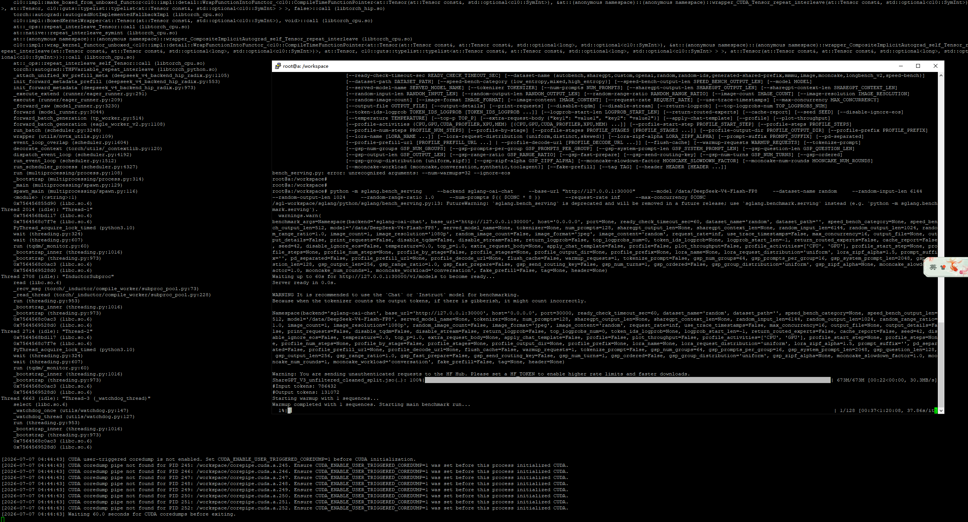

不开启MTP
- 启动参数
- docker run -itd \
- --ipc=host \
- --network=host \
- --privileged \
- --cap-add=CAP_SYS_ADMIN \
- --cap-add=SYS_PTRACE \
- --device=/dev/kfd \
- --device=/dev/dri \
- --security-opt seccomp=unconfined \
- --security-opt apparmor=unconfined \
- --group-add video \
- --name sglang_dsv4 \
- --shm-size 128G \
- -w /workspace \
- -v /data/:/data/ \
- -e HIP_VISIBLE_DEVICES=0,1,2,3,4,5,6,7 \
- -e SGLANG_USE_ROCM700A=0 \
- -e SGLANG_HACK_FLASHMLA_BACKEND=unified_kv_triton \
- -e AITER_BF16_FP8_MOE_BOUND=0 \
- --entrypoint=/bin/bash \
- lmsysorg/sglang-rocm:v0.5.14-rocm720-mi30x-20260706 \
- -c "sglang serve \
- --trust-remote-code \
- --model-path /data/DeepSeek-V4-Flash-FP8 \
- --tp 8 \
- --attention-backend dsv4 \
- --page-size 256 \
- --mem-fraction-static 0.90 \
- --swa-full-tokens-ratio 0.1 \
- --disable-shared-experts-fusion \
- --kv-cache-dtype fp8_e4m3 \
- --chunked-prefill-size 8192 \
- --host 0.0.0.0 \
- --port 30000 \
- &>> /data/sglang-log/sglang_deepseek_v4.log 2>&1"
- 请求测试
- time curl http://0.0.0.0:30000/v1/chat/completions -H "Content-Type: application/json" -d '{
- "model": "DeepSeek-V4-Flash-FP8",
- "messages": [
- {"role": "user", "content": "现在你的身份是刘备，而我是关羽，请在这个背景下完成对话。大哥，我等何日光复大汉"}
- ],
- "temperature": 0.6,
- "top_p": 0.95,
- "top_k": 20,
- "max_tokens": 2048
- }'
- {"id":"34c367aa50614695b83d62d97c5a12d4","object":"chat.completion","created":1783406907,"model":"DeepSeek-V4-Flash-FP8","choices":[{"index":0,"message":{"role":"assistant","content":"（轻抚长髯，目光深邃）二弟啊，你我兄弟自涿郡起兵，辗转数十载。今虽据有荆益，然汉贼未除，天下未定。待我修书一封与孔明，待他北伐之计议定，便是你我挥师中原之时。","reasoning_content":null,"tool_calls":null},"logprobs":null,"finish_reason":"stop","matched_stop":1}],"usage":{"prompt_tokens":27,"total_tokens":95,"completion_tokens":68,"prompt_tokens_details":null,"reasoning_tokens":0},"metadata":{"weight_version":"default"}}
- real 0m1.337s
- user 0m0.001s
- sys 0m0.005s
- Benchmark
- 1并发
- CONC=1

- python -m sglang.bench_serving \
- --backend sglang-oai-chat \
- --base-url "http://127.0.0.1:30000" \
- --model /data/DeepSeek-V4-Flash-FP8 \
- --dataset-name random \
- --random-input-len 6144 \
- --random-output-len 1024 \
- --random-range-ratio 1.0 \
- --num-prompts $(( $CONC * 8 )) \
- --request-rate inf \
- --max-concurrency $CONC \
- --warmup-requests $(( $CONC * 2 ))

- # 结果
- ============ Serving Benchmark Result ============
- Backend: sglang-oai-chat
- Traffic request rate: inf
- Max request concurrency: 1
- Successful requests: 8
- Benchmark duration (s): 158.18
- Total input tokens: 49152
- Total input text tokens: 49152
- Total generated tokens: 8192
- Total generated tokens (retokenized): 8048
- Request throughput (req/s): 0.05
- Input token throughput (tok/s): 310.73
- Output token throughput (tok/s): 51.79
- Peak output token throughput (tok/s): 56.00
- Peak concurrent requests: 2
- Total token throughput (tok/s): 362.51
- Concurrency: 1.00
- ----------------End-to-End Latency----------------
- Mean E2E Latency (ms): 19768.95
- Median E2E Latency (ms): 19543.33
- P90 E2E Latency (ms): 20773.31
- P95 E2E Latency (ms): 20865.73
- P99 E2E Latency (ms): 20939.67
- ---------------Time to First Token----------------
- Mean TTFT (ms): 1034.17
- Median TTFT (ms): 871.73
- P90 TTFT (ms): 1907.15
- P95 TTFT (ms): 1923.53
- P99 TTFT (ms): 1936.63
- -----Time per Output Token (excl. 1st token)------
- Mean TPOT (ms): 18.31
- Median TPOT (ms): 18.27
- P90 TPOT (ms): 18.48
- P95 TPOT (ms): 18.53
- P99 TPOT (ms): 18.58
- ---------------Inter-Token Latency----------------
- Mean ITL (ms): 18.52
- Median ITL (ms): 17.97
- P90 ITL (ms): 18.18
- P95 ITL (ms): 18.22
- P99 ITL (ms): 33.04
- Max ITL (ms): 92.27
- ==================================================
- 4并发
- CONC=4

- python -m sglang.bench_serving \
- --backend sglang-oai-chat \
- --base-url "http://127.0.0.1:30000" \
- --model /data/DeepSeek-V4-Flash-FP8 \
- --dataset-name random \
- --random-input-len 6144 \
- --random-output-len 1024 \
- --random-range-ratio 1.0 \
- --num-prompts $(( $CONC * 8 )) \
- --request-rate inf \
- --max-concurrency $CONC

- ============ Serving Benchmark Result ============
- Backend: sglang-oai-chat
- Traffic request rate: inf
- Max request concurrency: 4
- Successful requests: 32
- Benchmark duration (s): 231.44
- Total input tokens: 196608
- Total input text tokens: 196608
- Total generated tokens: 32768
- Total generated tokens (retokenized): 32597
- Request throughput (req/s): 0.14
- Input token throughput (tok/s): 849.49
- Output token throughput (tok/s): 141.58
- Peak output token throughput (tok/s): 164.00
- Peak concurrent requests: 8
- Total token throughput (tok/s): 991.08
- Concurrency: 4.00
- ----------------End-to-End Latency----------------
- Mean E2E Latency (ms): 28924.25
- Median E2E Latency (ms): 29017.98
- P90 E2E Latency (ms): 31085.10
- P95 E2E Latency (ms): 31144.81
- P99 E2E Latency (ms): 31145.58
- ---------------Time to First Token----------------
- Mean TTFT (ms): 2225.26
- Median TTFT (ms): 1970.94
- P90 TTFT (ms): 4995.86
- P95 TTFT (ms): 5216.24
- P99 TTFT (ms): 5366.08
- -----Time per Output Token (excl. 1st token)------
- Mean TPOT (ms): 26.10
- Median TPOT (ms): 25.58
- P90 TPOT (ms): 27.80
- P95 TPOT (ms): 28.17
- P99 TPOT (ms): 28.70
- ---------------Inter-Token Latency----------------
- Mean ITL (ms): 26.19
- Median ITL (ms): 24.62
- P90 ITL (ms): 24.78
- P95 ITL (ms): 33.68
- P99 ITL (ms): 38.53
- Max ITL (ms): 3391.24
- ==================================================

- 2并发
- CONC=2

- python -m sglang.bench_serving \
- --backend sglang-oai-chat \
- --base-url "http://127.0.0.1:30000" \
- --model /data/DeepSeek-V4-Flash-FP8 \
- --dataset-name random \
- --random-input-len 6144 \
- --random-output-len 1024 \
- --random-range-ratio 1.0 \
- --num-prompts $(( $CONC * 8 )) \
- --request-rate inf \
- --max-concurrency $CONC

- ============ Serving Benchmark Result ============
- Backend: sglang-oai-chat
- Traffic request rate: inf
- Max request concurrency: 2
- Successful requests: 16
- Benchmark duration (s): 200.40
- Total input tokens: 98304
- Total input text tokens: 98304
- Total generated tokens: 16384
- Total generated tokens (retokenized): 16179
- Request throughput (req/s): 0.08
- Input token throughput (tok/s): 490.54
- Output token throughput (tok/s): 81.76
- Peak output token throughput (tok/s): 84.00
- Peak concurrent requests: 4
- Total token throughput (tok/s): 572.30
- Concurrency: 2.00
- ----------------End-to-End Latency----------------
- Mean E2E Latency (ms): 25044.67
- Median E2E Latency (ms): 25062.04
- P90 E2E Latency (ms): 25305.71
- P95 E2E Latency (ms): 25356.95
- P99 E2E Latency (ms): 25357.54
- ---------------Time to First Token----------------
- Mean TTFT (ms): 209.91
- Median TTFT (ms): 208.64
- P90 TTFT (ms): 222.26
- P95 TTFT (ms): 231.08
- P99 TTFT (ms): 232.99
- -----Time per Output Token (excl. 1st token)------
- Mean TPOT (ms): 24.28
- Median TPOT (ms): 24.29
- P90 TPOT (ms): 24.52
- P95 TPOT (ms): 24.56
- P99 TPOT (ms): 24.56
- ---------------Inter-Token Latency----------------
- Mean ITL (ms): 24.51
- Median ITL (ms): 23.83
- P90 ITL (ms): 24.03
- P95 ITL (ms): 24.18
- P99 ITL (ms): 38.32
- Max ITL (ms): 143.06
- ==================================================

Benchmark 测试结果
- 并发数 | - 请求数 | - 输入长度 | - 输出长度 | - Input TPM (w) | - Output TPM (w) | - Total TPM (w) | - MEAN TTFT (s) | - MEAN TPOT (ms) | - MEAN E2E (s)
- 1 | - 8 | - 6144 | - 1024 | - 1.864 | - 0.311 | - 2.175 | - 1.034 | - 18.31 | - 19.77
2 | 16 | - 6144 | 1024 | 2.943 | 0.491 | 3.434 | 0.210 | 24.28 | 25.04
- 4 | - 32 | - 6144 | - 1024 | - 5.097 | - 0.850 | - 5.946 | - 2.225 | - 26.10 | - 28.92

locust压测
- 2并发
- # 1. 启动 locust 容器
- docker run -d \
- --network=host \
- -v /etc/localtime:/etc/localtime:ro \
- --shm-size=64g \
- --ipc=host \
- --privileged=true \
- --name locust-8089 \
- --entrypoint bash \
- locust-awcloud:1.5 \
- -c "sleep infinity"

- # 2. 启动 locust 服务
- docker exec -it locust-8089 bash
- cd /root/locust_test/
- nohup ./start_locust.sh &

- # 3. 开启 locust 压测
- curl --location 'http://127.0.0.1:8089/swarm' \
- --header 'Accept: */*' \
- --header 'Accept-Language: zh-CN,zh;q=0.9,en;q=0.8,de;q=0.7,zh-TW;q=0.6' \
- --header 'content-type: application/x-www-form-urlencoded' \
- --data-urlencode 'user_count=2' \
- --data-urlencode 'spawn_rate=1' \
- --data-urlencode 'host=http://127.0.0.1:30000' \
- --data-urlencode 'run_time=' \
- --data-urlencode 'profile=' \
- --data-urlencode 'api_key=' \
- --data-urlencode 'dataset_dir=' \
- --data-urlencode 'include_usage=true' \
- --data-urlencode 'interval=-1' \
- --data-urlencode 'max_tokens=16384' \
- --data-urlencode 'model_name=/data/DeepSeek-V4-Flash-FP8' \
- --data-urlencode 'sla_interval=300' \
- --data-urlencode 'thinking_enabled=false'
压测结果
- =======================================================================================================================================
- LOCUST PERFORMANCE REPORT - 2026-07-07 09:58:02
- State: running | Users: 2 | Workers: 8 | Total RPS: 0.0 | Fail Ratio: 0.0%
- ---------------------------------------------------------------------------------------------------------------------------------------
- Method | Name | Requests | Fails | Median | P95 | P99 | Average | Min | Max | RPS
- ---------------------------------------------------------------------------------------------------------------------------------------
- POST | /v1/chat/completions | 367 | 0 | 530 | 2900 | 4300 | 916.15 | 128 | 11457 | 0.00
- POST | LLM/E2E_5x | 36 | 0 | 26 | 61 | 67 | 29.15 | 15 | 67 | 0.00
- POST | LLM/TPM_Input_5x | 36 | 0 | 2 | 4 | 5 | 2.63 | 1 | 5 | 0.00
- POST | LLM/TPM_Output_5x | 36 | 0 | 0 | 1 | 1 | 0.49 | 0 | 1 | 0.00
- POST | LLM/TPM_Total_5x | 36 | 0 | 3 | 5 | 5 | 3.12 | 1 | 5 | 0.00
- POST | LLM/TPOT_5x | 36 | 0 | 25 | 27 | 29 | 24.97 | 22 | 29 | 0.00
- POST | LLM/TTFT_5x | 36 | 0 | 850 | 1400 | 1500 | 908.63 | 494 | 1495 | 0.00
- POST | LLM/input_len_usage_5x | 36 | 0 | 5700 | 8800 | 9600 | 5983.09 | 3367 | 9558 | 0.00
- POST | LLM/output_len_usage_5x | 36 | 0 | 1000 | 2400 | 2700 | 1127.63 | 533 | 2661 | 0.00
- - | Aggregated | 655 | 0 | 250 | 4400 | 7700 | 957.40 | 0 | 11457 | 0.00
- =======================================================================================================================================

